**Polio Eradication Support System**

Final Year Project Report by

**Subhan Ali Mangi**

**Syed Waqar Haider Bukhari**

In Partial Fulfillment

Of the Requirements for the degree Bachelors of Science (CS/SE)

Sukkur IBA University, Sukkur, Sindh Pakistan

(2021)

**DECLARATION**

We hereby declare that this project report entitled “Polio Eradication Support System” submitted to the “Department of Computer Science Sukkur IBA University”, is a record of an original work done by us under the guidance of Supervisor Mr. Ajmal Sawand and that no part has been plagiarized without citations. Also, this project work is submitted in the partial fulfillment of the requirements for the degree of Bachelor of Computer Science.

|  |  |
| --- | --- |
| **Team Members** | **Signature** |
| Subhan Ali Mangi | ______________ |
| Syed Waqar Haider | ______________ |
| **Supervisor:** | **Signature** |
| Ajmal Sawand | ______________ |
| **Date:** ______________ |  |
| **Place:** ______________ |  |
|  |  |

**DEDICATION**

*‘they only live, who live for others’ we dedicate this work to the pioneer of*

*Sukkur IBA University who always lived for others and established this meritorious institute. Our work is completely dedicated to*

***Mr. Nisar Ahmad Siddiqui - A Beacon of Light***

**ACKNOWLEDGEMENTS**

Thanks to Sukkur IBA University (SIBAU) & Oil and Gas Development Company Limited (OGDCL) Pakistan for jointly starting National Talent Hunt Program (NTHP) to facilitate needy and bright student in fulfilling their life goals.

Thanks to our parents who always prayed for our success and supported us on every phase of life.

Thanks to our supervisor of this project “Dr. Ajmal Sawand” for his continuous support and guidance, we also pay tribute to our co-supervisors “Dr. Sajid Khan”

and “Dr. Abdul Rehman Gilal” for their sincere help.

Thanks to every single soul of Sukkur IBA University.

Subhan Ali – Syed Waqar

***Table of Contents***

ABSTRACT 9

1. ................................................................................................................ Chapter 1: INTRODUCTION 10

1.1. Project Scope 10

1.2. Not in Scope 10

1.3. Project Background 10

1.4. Project Objectives 11

1.5. Stakeholders 11

1.6. Operating Environment 11

1.7. System Constraints 11

1.7.1. Software constraints 11

1.7.2. Hardware constraints 11

1.7.3. Legal constraints 11

1.7.4. Environmental constraints 11

1.7.5. User constraints 11

1.8. Assumptions & Dependencies 11

1.9. External Interface Requirements 12

1.9.1. Software Interfaces 12

1.9.2. Communications Interfaces 12

2. .................................................................................................... Chapter 2: LITERATURE REVIEW 13

3. ................................................................................ Chapter 3: REQUIREMENT SPECIFICATION 14

3.1. 3.1 Functional Requirements 14

3.2. Use Cases 14

3.2.1. Login 14

3.2.2. Register 15

3.2.3. Send GPS Coordinates 16

3.2.4. Update Profile 17

3.2.5. Fill Data 18

3.2.6. Complete Visit 19

3.2.7. View Feedback 20

3.2.8. Check Polio Worker 21

3.2.9. Register Complaint 22

3.2.10. Create PolioWorker 23

3.3. Non-functional Requirements 24

3.3.1. Performance Requirements 24

3.3.2. Safety Requirements 24

3.3.3. Security Requirements 24

3.3.4. User Documentation 24

4. .................................................................................................. Chapter 4: PROBLEM DEFINITION 25

4.1. PROBLEM DESCRIPTION 25

4.2. SOLUTION 26

4.2.1. Citizen App 26

4.2.2. Polio Worker App 26

4.2.3. Monitoring Dashboard 26

5. ................................................................................................................ Chapter 5: METHODOLOGY 27

5.1. Purpose 27

5.2. Software Development Methodology 27

5.2.1. Agile Methodology 27

5.3. Use Case Diagram 28

5.3.1. Citizen App 28

5.3.2. Monitoring Portal 29

5.3.3. Polio Worker App 30

5.4. Class Diagram 31

5.4.1. Polio Worker 31

5.4.2. Citizen 31

5.4.3. Feedback 31

5.4.4. Child 31

5.4.5. Login 31

5.4.6. Signup 31

5.5. Sequence Diagram 32

5.6. ER Diagram 32

5.6.1. Admin 32

5.6.2. Polio Worker 33

5.6.3. Citizen 33

5.6.4. Feedback 33

5.6.5. Complaint 33

5.6.6. Polio Worker Coordinates 33

5.6.7. Polio Worker Visit Location 33

5.6.8. Vaccination 33

6. .............................................................................................. Chapter 6: SYSTEM ARCHITECTURE 34

6.1. SYSTEM ARCHITECTURE 34

6.2. DATA FLOW DIAGRAM 35

7. ............................................................................ Chapter 7: IMPLEMENTATION AND TESTING 36

7.1. Tools & Techniques 36

7.1.1. Android Studio 36

7.1.2. MySQL Database: 36

7.1.3. RESTful APIs: 36

7.1.4. Google Maps API: 36

7.1.5. Laravel: 36

8. .......................................................................................... Chapter 8: RESULTS AND DISCUSSION 37

8.1. Purpose 37

8.2. Polio Worker App 37

8.2.1. Splash Screen 37

8.2.2. Home Screen 38

8.2.3. Add Record Screen 39

8.2.4. Profile Screen 40

8.3. Citizen App 41

8.3.1. Home 41

8.3.2. View Polio Worker Details 42

8.3.3. Notifications 43

8.3.4. Profile 44

8.4. Monitoring Portal 45

8.4.1. Dashboard 45

8.4.2. Add Polio Worker 46

8.4.3. View Polio Worker 47

8.4.5. View Complaints 48

8.4.6. View Feedbacks 49

9. ........................................................................... Chapter 9: CONCLUSION AND FUTURE WORK 50

9.1. Conclusion 50

9.2. Future Work 50

10. .................................................................................................................. Chapter 10: REFERENCES 51

***Table of Figures***

*FIGURE 1: AGILE SOFTWARE DEVELOPMENT [14] __________________________________________________________ 27* *FIGURE 2: USE CASE DIAGRAM CITIZEN ______________________________________________________________________ 28* *FIGURE 3: USE CASE DIAGRAM DASHBOARD_________________________________________________________________ 29* *FIGURE 4: USE CASE DIAGRAM POLIO APP ___________________________________________________________________ 30* *FIGURE 5: CLASS DIAGRAM ____________________________________________________________________________________ 31* *FIGURE 6: SEQUENCE DIAGRAM ______________________________________________________________________________ 32* *FIGURE 7: ENTITY-RELATIONSHIP DIAGRAM ________________________________________________________________ 32* *FIGURE 8: SYSTEM ARCHITECTURE __________________________________________________________________________ 34* *FIGURE 9: DATA FLOW DIAGRAM _____________________________________________________________________________ 35* *FIGURE 10: SPLASH ____________________________________________________________________________________________ 37* *FIGURE 11: HOME SCREEN ____________________________________________________________________________________ 38* *FIGURE 12: ADD RECORD SCREEN ____________________________________________________________________________ 39* *FIGURE 13: PROFILE SCREEN _________________________________________________________________________________ 40* *FIGURE 14: WORKER DETAILS SCREEN ______________________________________________________________________ 41* *FIGURE 15: HOME SCREEN 3 __________________________________________________________________________________ 41*

*FIGURE 16: HOME SCREEN 2 __________________________________________________________________________________ 41* *FIGURE 17: POLIO WORKER DETAILS ________________________________________________________________________ 42* *FIGURE 18: NOTIFICATION AREA _____________________________________________________________________________ 43* *FIGURE 19: PROFILE SCREEN 2 _______________________________________________________________________________ 44*

*FIGURE 20: DASHBOARD ______________________________________________________________________________________ 45*

*FIGURE 21: ADD WORKER _____________________________________________________________________________________ 46* *FIGURE 22: VIEW WORKERS __________________________________________________________________________________ 47*

*FIGURE 23: VIEW COMPLAINS ________________________________________________________________________________ 48*

*FIGURE 24: VIEW FEEDBACKS ________________________________________________________________________________ 49*

# ABSTRACT

Polio or poliomyelitis is a highly infectious virus that directly attacks someone’s brain and spinal cord, which results in permanent paralysis of different organs and leads to permanent disability. Currently, in the world, Pakistan is among the two countries including Afghanistan as second where still polio is considered to be an endemic viral infection. Along with other countries Pakistan has also been fighting polio virus since 1994.

This project proposes a polio workers' monitoring system having a focus on issues faced by citizens, polio workers, and the health department. This live monitoring system of polio workers will be helpful and beneficial for the government to have a check and balance on overall statistics of a particular area such as how many places are covered and how many places are still to cover. The citizen would be enabled to see the profile of the polio worker which is assigned to their area and can initiate a complaint if any. The health department will use this tool to see the performance and tracking of the polio workers individually. The record will be maintained digitally on the go as this will be beneficial for the government to keep a record online.

We aim to make a small contribution as our country can increase its pace to fight against polio and reduce polio cases.

# 1. Chapter 1: INTRODUCTION

The world has gone through many epidemics and viruses, Polio or poliomyelitis is a deadly infectious disease which is caused by Polio Virus which spreads person to person and directly attacks one persons’ brain and spinal cord which leads to paralysis. 1 in 200 infected patients leads to permanent paralysis, and from those paralyzed 5-10% die when their breathing muscles become blocked. [1]. Pakistan is among the two remaining countries where still Polio is considered as an endemic viral infection [2]. Since 1988, the Polio vaccine has saved around 18 million people from being paralyzed and 1.5 million children’s deaths have been averted [1]. Pakistan's government started a polio immunization campaign back in 1994 and started eradicating polio officially from 1994 [3].

Polio Eradication Support System (PESS) is an initiative to help the polio team and government to fasten pace against polio with the help of IT. Through digital monitoring it will help polio teams to cover nearly the whole country and no child will be left unvaccinated. Through this system, citizens will have a dedicated app where they can log in and see which polio worker will visit them. If a polio worker has already visited their house, then they can give feedback about the visit and can complain if the polio worker has not visited them yet. This will help to identify uncovered areas. The complaints will be shown to the admin portal where they can see complaints if any. Admin team can also track any polio worker.

Each polio worker will have a dedicated account, created, and verified by the admin portal. Upon visit polio workers will add details related to citizens like number of children vaccinated and their data. The data will be recorded digitally and will be presented to the admin portal only. Once a polio worker will complete the visit then all citizens in that area will be notified that polio worker has visited your area and you can give feedback or complain.

This digital system will help polio teams to cover maximum area and will help identify uncovered areas quickly and easily. The result will be for greater good. If the majority of the country is vaccinated each month then we will soon see Pakistan in the list of polio free countries, Insha Allah.

## 1.1. Project Scope

The aim of this project is to develop a polio workers’ monitoring system using mobile application and GPS technology to keep track of polio workers to help them reduce polio virus from Pakistan. Polio workers will login in their mobile app and their GPS coordinates would be recorded repeatedly in order to track them. Citizens can also see which polio worker will visit them this month if the visit would not take place the citizens could also file a complaint. Citizens would have their own app which can be registered through email and Computerized National Identity Card (CNIC). The system admin can track any polio worker and can respond to any complaint generated by citizens in their web portal environment*.*

## 1.2. Not in Scope

The functionalities like assigning random polio workers to an area using machine learning is not included in this project.

## 1.3. Project Background

The world has gone through many epidemics and viruses, Polio or poliomyelitis is a deadly infectious disease which is caused by Polio Virus which spreads person to person and directly attack one persons’ brain and spinal cord which leads to paralysis. 1 in 200 infected patients lead to permanent paralysis, and from those paralyzed 5-10% die when their breathing muscles become blocked.[1]. Pakistan is among two remaining countries where still Polio is considered as an endemic viral infection [2]. Since 1988, the Polio vaccine has saved around 18 million people from being paralyzed and 1.5 million children’s deaths has been averted [1]. The record of polio workers is still on paper. The tracking of polio workers is done by supervisors manually whether they covered their assigned areas or not.

## 1.4. Project Objectives

The objective of this project is to make a real time tracking and monitoring system of Polio Workers. Through this project, there will be real time tracking of polio workers. The citizens would be able to see which polio worker is assigned to cover their area; they would also be enabled to submit complaints about polio workers if any.

The polio workers will be given a tablet or android phone on which our application would be installed. Polio worker’s account will be created by monitoring portal admin. The GPS coordinates of their mobile phones will be used to track polio workers in real time. Health Department officials will be tracking polio workers through a designed dashboard. When a polio worker provides vaccines to a child, he will record the data through application by entering the CNIC details of the father/guardian of the child or by manually entering the data.

## 1.5. Stakeholders

The stakeholders of this software system include the citizens of Pakistan who would use this app to see which polio worker is visiting them in this drive, Polio workers who will use the system for their tracking. The government officials who will be keeping track of different polio workers and the development team who will develop this system.

## 1.6. Operating Environment

This software will run on Android operating system 4.0+. Any version of Android later than 4.0 is needed to use this app. The GPS of the mobile device will be used on which Polio Worker will login its account. The web portal for tracking of Polio Workers will be run on any web hosting.

## 1.7. System Constraints

### 1.7.1. Software constraints

* Operating System of mobile can stop working due to any software failure
* Internet is needed for sending coordinates to database

### 1.7.2. Hardware constraints

* Mobile device should have GPS Receiver
* Cultural constraints (includes language etc.)
* User should have knowledge about English language

### 1.7.3. Legal constraints

• Government should accept this project if we make it available for public

### 1.7.4. Environmental constraints

• High mountains and remote areas can pay hindrances when sending coordinates to internet

### 1.7.5. User constraints

• The mobile application is developed for Polio Workers, so they usually are untrained when we talk about IT. We will focus on more graphical modes rather than textual to avoid any difficulties for the users.

## 1.8. Assumptions & Dependencies

* User should have active internet connection all the time
* User is not from any remote area like from where he/she can’t send/receive GPS signals

## 1.9. External Interface Requirements

### 1.9.1. Software Interfaces

The mobile application will access the internet of the device and will send/receive GPS signals. The mobile device would be sending GPS coordinates to our database through which we would be able to determine the location and tracking of the polio worker. Google Maps API will help us to determine the location of the user.

### 1.9.2. Communications Interfaces

We will use internet through device’s network module such as WIFI or GSM. The data would be sent over the internet to our remote database. The data would be encapsulated into a JSON object and would be directly stored to the database.

# 2. Chapter 2: LITERATURE REVIEW

Although there isn’t any similar work done for the effective vaccination of polio, however, there is a lot of work done in the field of real-time location-based services through GPS-enabled mobile phones for various applications. In “The Travel Assistant Device: Utilizing Gps-Enabled Mobile Phones To Aid Transit Riders With Special Needs” [4] they proposed a system/service in which riders were being monitored on real-time and given audio or visual real-time instructions through prompt on their cell phone, their location is monitored on a system on real-time.

Kamran et al. [5] state how Careem and Uber track the riders in real-time using GPA and the internet. Riders having the application installed in mobile phones, the data is sent to the Careem/Uber database and they are tracked in real-time on both customer and Careem/Uber end.

Lee et al. [6] designed a real-time vehicle tracking system using GPS and GRSM modules to have real-time tracking of vehicles. They used Google Maps API to see the vehicles in their designed mobile application.

Fisher, J. A., & Monahan, T. [10] designed a system whose purpose is to access the real time location systems that are implemented in the U.S hospitals. The types of uses of real-time location systems are examined as well as the amount of functionality of software and hardware. In this research it was found that the best use of RTLS is for asset tracking.

Lin, P., Li, Q., Fan, Q., Gao, X., & Hu, S. [11] Proposed a system that is based on the feasibility of a real-time tunnel location-based services (LBS) system to ensure worker safety and deliver a variety of services at the concrete dam site. Together with this study another study was proposed by Lee, Kwang-Pyo [12] on a real-time location based labor safety management system that was developed by integrating a real-time locating system for tracking workers' current location; a position monitoring system for mapping workers' whereabouts on a computerised building model; and alarm technology for giving out early warnings.

Moreover, Gholamhosseini, L., Sadoughi, F., & Safaei, A. [13] Proposed the Hospital Real-time Location Systems (HRTLS) to monitor patients, medical personnel, and vital medical equipment in situations of emergencies. The study's goal was to offer Hospital Real-Time Location Systems in Iran using cutting-edge technologies. The purpose of this study was to recognize the current status and keep an update on the performance of hospital real-time location systems.

# 3. Chapter 3: REQUIREMENT SPECIFICATION

## 3.1. 3.1 Functional Requirements

## 3.2. Use Cases

### 3.2.1. Login

The use case is about the” login” of Citizen/ Polio Worker. This use case includes the Unique email and Password features that will be used to login into the accounts that are registered already*.*

|  |  |  |  |  |
| --- | --- | --- | --- | --- |
| ***<Use case Id: Login>*** | | | | |
| ***Use case Id:*** | | 1 | | |
| ***Actors:***  Polio worker, Citizen | | | | |
| ***Feature:*** Email, Password | | | | |
| ***Pre-condition:*** | | The user must be registered before logging in | | |
| ***Scenarios*** | | | | |
| ***Step#*** | ***Action*** | | | ***Software Reaction*** |
| ***1.*** | User enters the Email and Password | | | System matches the login details with database |
| ***2.*** | *User gets login* | | | *System transfers the user towards main page* |
|  |  | | |  |
| ***Alternate Scenarios:*** | | | | |
| ***1a: User forgets the password: User will be asked to re-set the password by using alternative options*** | | | | |
| ***Post Conditions*** | | | | |
| ***Step#*** | ***Description*** | | | |
| ***1*** | The user will be re directed towards his/her account. | | | |
|  |  | | | |
|  |  | | | |
| ***Use Case Cross referenced*** | | | Register | |

### 3.2.2. Register

The use case is used to register the Citizen. A user can register him/herself if they are not already registered with the same email. ID needs to be a unique one. The database will check if the user already exists, if not then he/she will be registered.

|  |  |  |  |  |
| --- | --- | --- | --- | --- |
| ***<Use case Id: Register>*** | | | | |
| ***Use case Id:*** | | 3 | | |
| ***Actors:***  Citizen | | | | |
| ***Feature:*** Password , Email, phone No | | | | |
| ***Pre-condition:*** | | The user is not registered already | | |
| ***Scenarios*** | | | | |
| ***Step#*** | ***Action*** | | | ***Software Reaction*** |
| ***1.*** | User enters a unique email and password to register. | | | System checks if the account with this Email ID already exists |
| ***2.*** | *User completes registration after not getting any error* | | | *System records the citizen identity in bank end database* |
| ***3.*** | *Registration is ended* | | |  |
| ***1a: Citizen account already exists: The user may have an account registered on the email due to which user needs to change the email or ID to register.*** | | | | |
| ***Post Conditions*** | | | | |
| ***Step#*** | ***Description*** | | | |
| ***1*** | The citizens are registered and can login now into their accounts. | | | |
|  |  | | | |
|  |  | | | |
| ***Use Case Cross referenced*** | | | none | |

### 3.2.3. Send GPS Coordinates

The use case is about “Sending GPS coordinates”. The GPS will be turned on so that to perform the real time tracking. One the location is found out; the Polio worker will view the location to visit so that the coordinated will be directed towards the specified location.

|  |  |  |  |  |
| --- | --- | --- | --- | --- |
| ***<Use case Id: Send GPS Coordinates>*** | | | | |
| ***Use case Id:*** | | 4 | | |
| ***Actors:***  Database | | | | |
| ***Feature:*** location, x, y coordinates | | | | |
| ***Pre-condition:*** | | Select a location for real time tracking | | |
| ***Scenarios*** | | | | |
| ***Step#*** | ***Action*** | | | ***Software Reaction*** |
| ***1.*** | GPS will set its coordinates at a nearby location | | | System turns on the location updates for real time tracking |
| ***2.*** | *GPS finds out the location to visit* | | | *System directs the coordinates towards the location* |
| ***3.*** | *Polio worker views the location to visit* | | |  |
| ***1a: GPS error: GPS turns off at the time of tracking due to which loss in signals takes place or connectivity issue occurs till the signals are restored.*** | | | | |
| ***Post Conditions*** | | | | |
| ***Step#*** | ***Description*** | | | |
| ***1*** | The real time tracking is established. | | | |
|  |  | | | |
|  |  | | | |
| ***Use Case Cross referenced*** | | | none | |

### 3.2.4. Update Profile

The use case is about the” Update Profile “. It is used when the citizen/polio work wants to edit or change their profile and its details

|  |  |  |  |  |
| --- | --- | --- | --- | --- |
| ***<Use case Id: Update Profile>*** | | | | |
| ***Use case Id:*** | | 5 | | |
| ***Actors:***  Polio worker, Citizen | | | | |
| ***Feature:*** Profile, email, password | | | | |
| ***Pre-condition:*** | | The user must have an account | | |
| ***Scenarios*** | | | | |
| ***Step#*** | ***Action*** | | | ***Software Reaction*** |
| ***1.*** | User edits or changes the profile and its details | | | System confirms the changes and updates the record |
| ***2.*** |  | | |  |
|  |  | | |  |
| ***None.*** | | | | |
| ***Post Conditions*** | | | | |
| ***Step#*** | ***Description*** | | | |
| ***1*** | The user profile will be updated | | | |
|  |  | | | |
|  |  | | | |
| ***Use Case Cross referenced*** | | | Register | |

### 3.2.5. Fill Data

The use case is about the” Fill data“ which will be used by the polio worker to fill the data after vaccinated the children of the citizen.

|  |  |  |  |  |
| --- | --- | --- | --- | --- |
| ***<Use case Id: Fill Data>*** | | | | |
| ***Use case Id:*** | | 6 | | |
| ***Actors:***  Polio worker, Citizen | | | | |
| ***Feature:*** CNIC, database | | | | |
| ***Pre-condition:*** | | The polio worker has vaccinated the citizen’s children | | |
| ***Scenarios*** | | | | |
| ***Step#*** | ***Action*** | | | ***Software Reaction*** |
| ***1.*** | Polio workers give polio vaccine to the children | | | System scans the citizen record in the database |
| ***2.*** | *Then the worker fills the data after scanning CNIC.* | | | *Database is updated* |
|  |  | | |  |
| ***None.*** | | | | |
| ***Post Conditions*** | | | | |
| ***Step#*** | ***Description*** | | | |
| ***1*** | New data is added into the record | | | |
|  |  | | | |
|  |  | | | |
| ***Use Case Cross referenced*** | | | none | |

### 3.2.6. Complete Visit

The use case “Complete Visit” is marked as complete once the polio worker completes its visit to the citizen’s location and fills the data after vaccination has completed.

|  |  |  |  |  |
| --- | --- | --- | --- | --- |
| ***<Use case Id: Complete Visit>*** | | | | |
| ***Use case Id:*** | | 8 | | |
| ***Actors:***  Polio worker, Citizen | | | | |
| ***Feature:*** database, fill data | | | | |
| ***Pre-condition:*** | | The citizen’s children are vaccinated | | |
| ***Scenarios*** | | | | |
| ***Step#*** | ***Action*** | | | ***Software Reaction*** |
| ***1.*** | Polio worker enters the location to give polio to children | | | System fetches the data from nadra’s data about the citizen using CNIC |
| ***2.*** | *Polio worker fills the data and updates it into database* | | | *System updates the database* |
| ***3*** | *He then marks his visit as complete in the application* | | |  |
| ***none*** | | | | |
| ***Post Conditions*** | | | | |
| ***Step#*** | ***Description*** | | | |
| ***1*** | The vaccination is completed at the location set | | | |
|  |  | | | |
|  |  | | | |
| ***Use Case Cross referenced*** | | | Register | |

### 3.2.7. View Feedback

The use case “View Feedback” will be used to get the feedback from the services provided to the citizen by the Polio worker.

|  |  |  |  |  |
| --- | --- | --- | --- | --- |
| ***<Use case Id: View Feedback>*** | | | | |
| ***Use case Id:*** | | 9 | | |
| ***Actors:***  Citizen | | | | |
| ***Feature:*** Id | | | | |
| ***Pre-condition:*** | | The visit is completed | | |
| ***Scenarios*** | | | | |
| ***Step#*** | ***Action*** | | | ***Software Reaction*** |
| ***1.*** | The citizen will give feedback to the polio worker using their account, also to rate their service once the visit to their location is completed | | | System records the feedback |
|  |  | | |  |
|  |  | | |  |
| ***None.*** | | | | |
| ***Post Conditions*** | | | | |
| ***Step#*** | ***Description*** | | | |
| ***1*** | The citizen response is recorded | | | |
|  |  | | | |
|  |  | | | |
| ***Use Case Cross referenced*** | | | Visit completed | |

### 3.2.8. Check Polio Worker

The use case “Check Polio Worker” is about that: The citizen will be able to check the profile of the polio worker who will be going to visit their area this time.

|  |  |  |  |  |
| --- | --- | --- | --- | --- |
| ***<Use case Id: Login>*** | | | | |
| ***Use case Id:*** | | 10 | | |
| ***Actors:***  Polio worker, Citizen | | | | |
| ***Feature:*** Id, Password, profile | | | | |
| ***Pre-condition:*** | | The profile of polio worker exists | | |
| ***Scenarios*** | | | | |
| ***Step#*** | ***Action*** | | | ***Software Reaction*** |
| ***1.*** | The citizen logs in to their account | | | System directs user to main page |
| ***2.*** | *The citizen searches out for the polio worker visiting their area this time* | | | *System provides the details about the polio worker from database* |
|  |  | | |  |
| ***none*** | | | | |
| ***Post Conditions*** | | | | |
| ***Step#*** | ***Description*** | | | |
| ***1*** | The citizen will know about the polio worker who is visiting their area. | | | |
|  |  | | | |
|  |  | | | |
| ***Use Case Cross referenced*** | | | Register | |

### 3.2.9. Register Complaint

The citizen will be able to register the complaint against any polio worker who have visited their area for polio vaccination.

|  |  |  |  |  |
| --- | --- | --- | --- | --- |
| ***<Use case Id: Register Complaint>*** | | | | |
| ***Use case Id:*** | | 11 | | |
| ***Actors:***  Citizen | | | | |
| ***Feature:*** Email, Password | | | | |
| ***Pre-condition:*** | | The user is login to their account | | |
| ***Scenarios*** | | | | |
| ***Step#*** | ***Action*** | | | ***Software Reaction*** |
| ***1.*** | Citizen fills out the complaint against the polio worker or the services provided by them | | | System records the complaint in their feedbacks so to take action on it later. |
|  |  | | |  |
|  |  | | |  |
| ***None.*** | | | | |
| ***Post Conditions*** | | | | |
| ***Step#*** | ***Description*** | | | |
| ***1*** | The citizen complaint is recorded | | | |
|  |  | | | |
|  |  | | | |
| ***Use Case Cross referenced*** | | | Log in | |

### 3.2.10. Create PolioWorker

The polio worker will be registered by the Administrator/Admin through the dashboard.

|  |  |  |  |  |
| --- | --- | --- | --- | --- |
| ***<Use case Id: Create Polio Worker>*** | | | | |
| ***Use case Id:*** | | 12 | | |
| ***Actors:***  Polio Worker | | | | |
| ***Feature:*** Email, Password | | | | |
| ***Pre-condition:*** | | The polio worker has provided the details to the admin | | |
| ***Scenarios*** | | | | |
| ***Step#*** | ***Action*** | | | ***Software Reaction*** |
| ***1.*** | The admin will register the polio worker on the basis of emailId and password | | | The system asks for the confirmation before and then creates the account. |
|  |  | | |  |
|  |  | | |  |
| ***None.*** | | | | |
| ***Post Conditions*** | | | | |
| ***Step#*** | ***Description*** | | | |
| ***1*** | The polio worker is registered. | | | |
|  |  | | | |
|  |  | | | |
| ***Use Case Cross referenced*** | | | Register | |

## 3.3. Non-functional Requirements

### 3.3.1. Performance Requirements

* Reliability o The system is available when needed - Availability o Fault Tolerance
* Performance
* Efficiency o The system saves time
  + The system uses resources efficiently
* Maintainability o Testability of the system o The system should be modifiable o The system can be expanded
* Usability o The user interface should be simple and user-friendly
  + The code should be simple o The system should be easy to learn

### 3.3.2. Safety Requirements

The internet should be turned off when the user is not using the system. Excessive use of data can result in financial loss to the user.

### 3.3.3. Security Requirements

The system uses GPS and internet data of the system which the user will authorize once registered for the use of the system.

### 3.3.4. User Documentation

We will provide users with a user's manual and our contact details inside the application if they need any help then we will be available for them.

# 4. Chapter 4: PROBLEM DEFINITION

## 4.1. PROBLEM DESCRIPTION

The record of polio workers is still on paper. The tracking of polio workers is done by supervisors manually whether they covered their assigned areas or not. The polio staff is assigned areas manually by supervisors and there is no track record that if areas are covered or not. The health department is unable to track which area is vulnerable to the virus due to the lack of a monitoring system for polio workers.

The objective of this project is to make a real-time tracking and monitoring system of Polio Workers. Through this project, there will be real-time tracking of polio workers. The citizens would be able to see which polio worker is assigned to cover their area; they would also be enabled to submit complaints about polio workers if any.

The targeted customers for this project are devised into three categories, citizens, polio workers, and the health department of government. The citizens’ interest will be to see the assigned polio worker and their profile. They can authenticate a person when they arrive at their place. If the polio vaccination drive is not carried in announced dates then citizens would be enabled to initiate a complaint. All the citizens of Pakistan will be categorized in this category of the targeted audience.

The polio workers will use a special application designed for them while commencing the polio drive. The application will be capable of tracking the location they traveled by using GPS for live monitoring purposes. When vaccinating children, they will scan the CNIC of parent/guardian to get their data from the database then they will input the number of vaccinated children. This will solve the problem of record-keeping offline.

The government health department will have a specially designed monitoring system where they will see statistics related to polio workers, like how many children a polio worker has covered. The admin can also view complaints made against a polio worker and feedback too if any. They will be enabled to track the progress of any polio worker on the portal given.

## 4.2. SOLUTION

Our solution PESS consisted of two android apps and one admin dashboard described below.

### 4.2.1. Citizen App

A mobile application will be provided. The citizen can create and login to their account using National Identification Card (NIC), can maintain their profile, and can check the worker profile which is assigned to their area for vaccination drive. They can also submit complaint against workers if they missed the vaccination drive.

### 4.2.2. Polio Worker App

A tablet-based android application will be provided to the worker. Through this application, the worker will sign in his account to keep his performance record. The worker’s application will send his live location coordinates to the database to help citizens and the monitoring body to track the worker. He will enter citizen CNIC and enter the number of children to be vaccinated, after that he will add data related to children associated with citizens. Once he will finish the vaccination survey he marks as done in the application. After a successful visit, all citizens of that area will get notification of that visit and citizens will be able to provide review or complain.

### 4.2.3. Monitoring Dashboard

A desktop-based application will be provided for monitoring purposes. They can track the location of polio worker with the help of GPS coordinates accessing from the database. They can see the covered and uncovered citizens by polio workers. They can also check the reviews of workers given by the citizens at that place. The complaints generated by citizens will be visible to the admin dashboard.

# 5. Chapter 5: METHODOLOGY

## 5.1. Purpose

Thischapter is about defining and describing the design methodology we followed while making our Polio Eradication Support System app. This section will also provide a list of requirements to test the final product to determine whether we are successful in implementing the system according to the proposed design.

## 5.2. Software Development Methodology

While working on any software project it becomes necessary to follow any methodology. There are two popular methodologies one is Waterfall methodology the other is agile methodology. By keeping the nature of our software and necessity of the project we decided to follow agile methodology for our FYP. The agile methodology helped us to give the current shape to our project Polio Eradication Support System (PESS). We believe that without following Agile Methodology it would have been very difficult to complete this project.

### 5.2.1. Agile Methodology

Agile methods for software development emerged in the mid 1990s [7, 8] and focus on agility for software development. In essence, agility means responding to changes quickly and efficiently [9]. Agile development methodology is the easiest methodology in software development because of its iterative, team-based approach to the development. We don’t create schedules and timelines but we create sprints in agile development to reach our desired goal.

Some of the benefits of agile development we came across our development cycle are as follows:

* It was so simple and easy to use
* We were focused during our project development
* We can decide changes at any time during the development of our app
* It was a better methodology to control complete project development
* The final product was of superior quality

Figure SEQ Figure \* ARABIC 1. Agile

**FIGURE 1: AGILE SOFTWARE DEVELOPMENT [14]**

## 5.3. Use Case Diagram

### 5.3.1. Citizen App

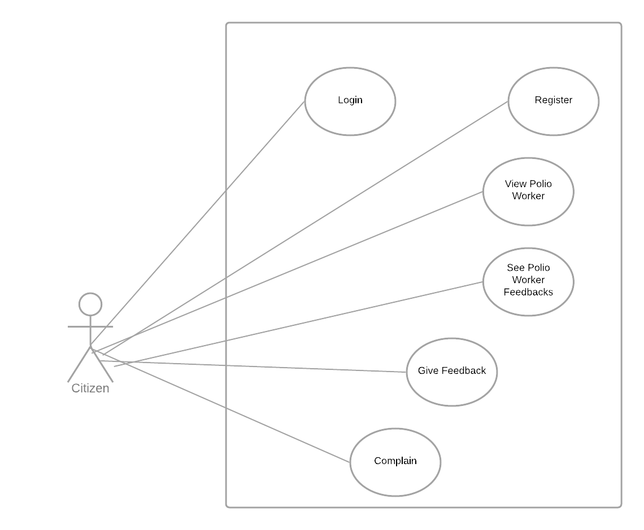

**FIGURE 2: USE CASE DIAGRAM CITIZEN**

### 5.3.2. Monitoring Portal

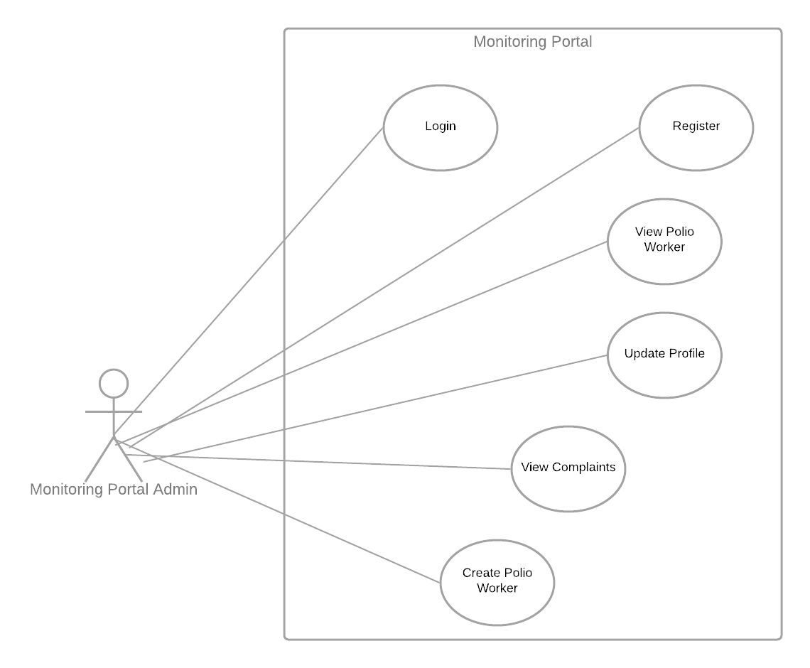

**FIGURE 3: USE CASE DIAGRAM DASHBOARD**

### 5.3.3. Polio Worker App

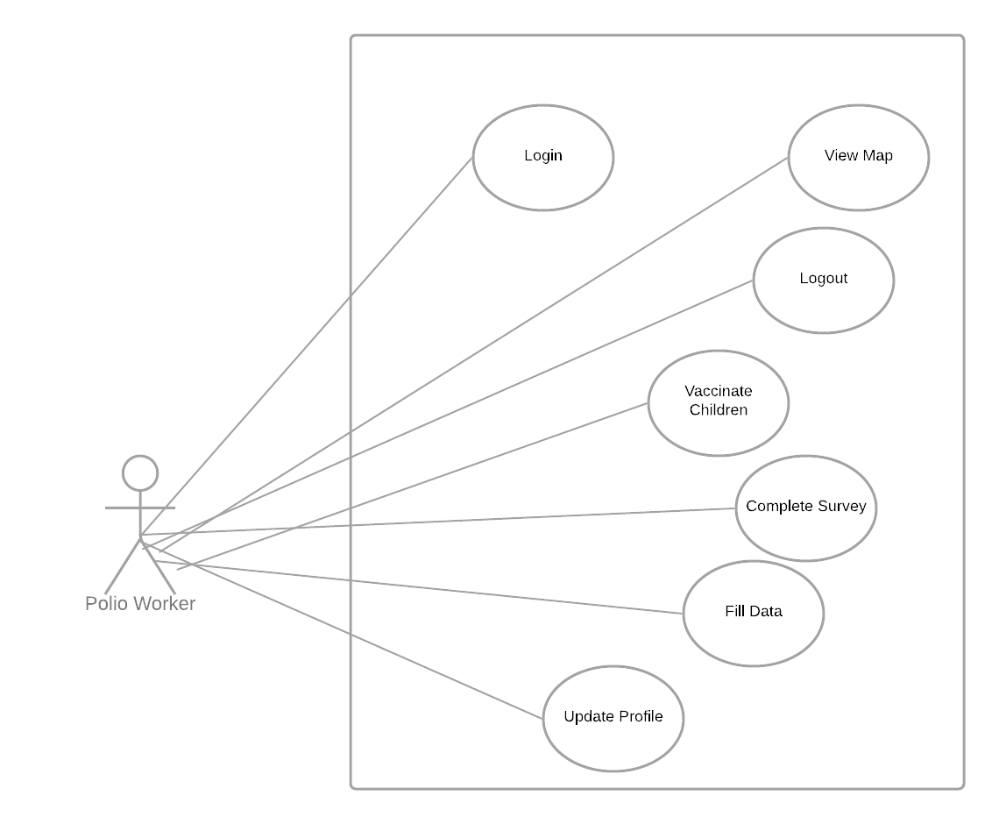

**FIGURE 4: USE CASE DIAGRAM POLIO APP**

## 5.4. Class Diagram

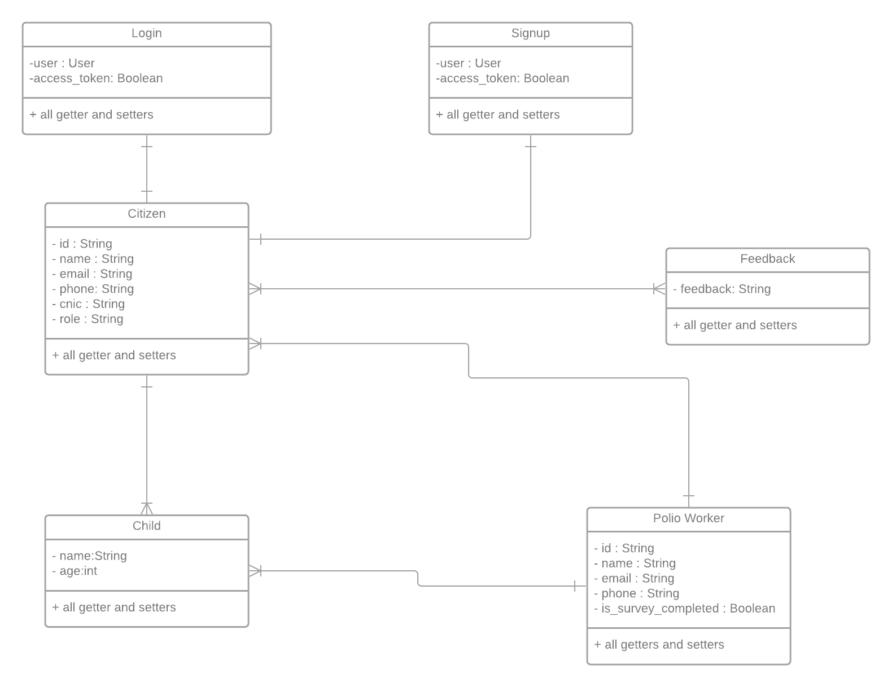

**FIGURE 5: CLASS DIAGRAM**

These are some of the important classes in our system, although we have an android app so there are a lot of classes of activities and fragments so we have included some important classes here.

### 5.4.1. Polio Worker

We have made this class to represent polio workers in our system. Details about polio workers are discussed in detail in previous sections.

### 5.4.2. Citizen

We have made this class to represent citizens in our system. Details about Citizens are discussed in detail in previous sections.

### 5.4.3. Feedback

Citizens are provided a facility to send feedback to our system for polio workers so we have created this for them.

### 5.4.4. Child

This class is for representing the Child of citizens which are to be vaccinated.

### 5.4.5. Login

This class is specially designed for logging into the system

### 5.4.6. Signup

This class is for registering into the app

## 5.5. Sequence Diagram

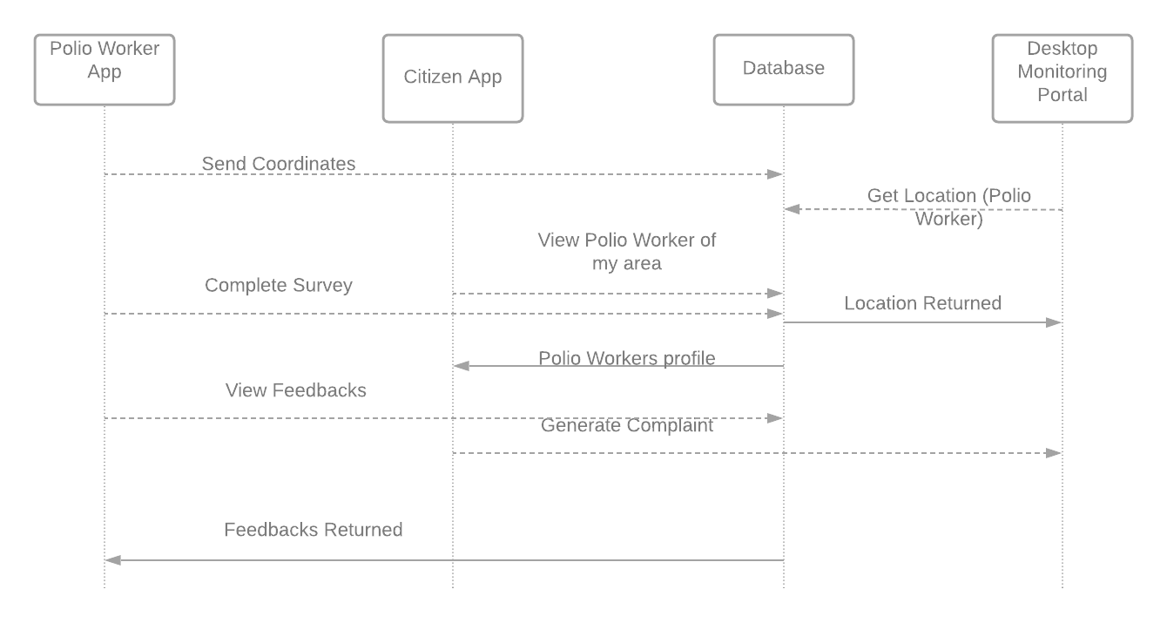

**FIGURE 6: SEQUENCE DIAGRAM**

## 5.6. ER Diagram

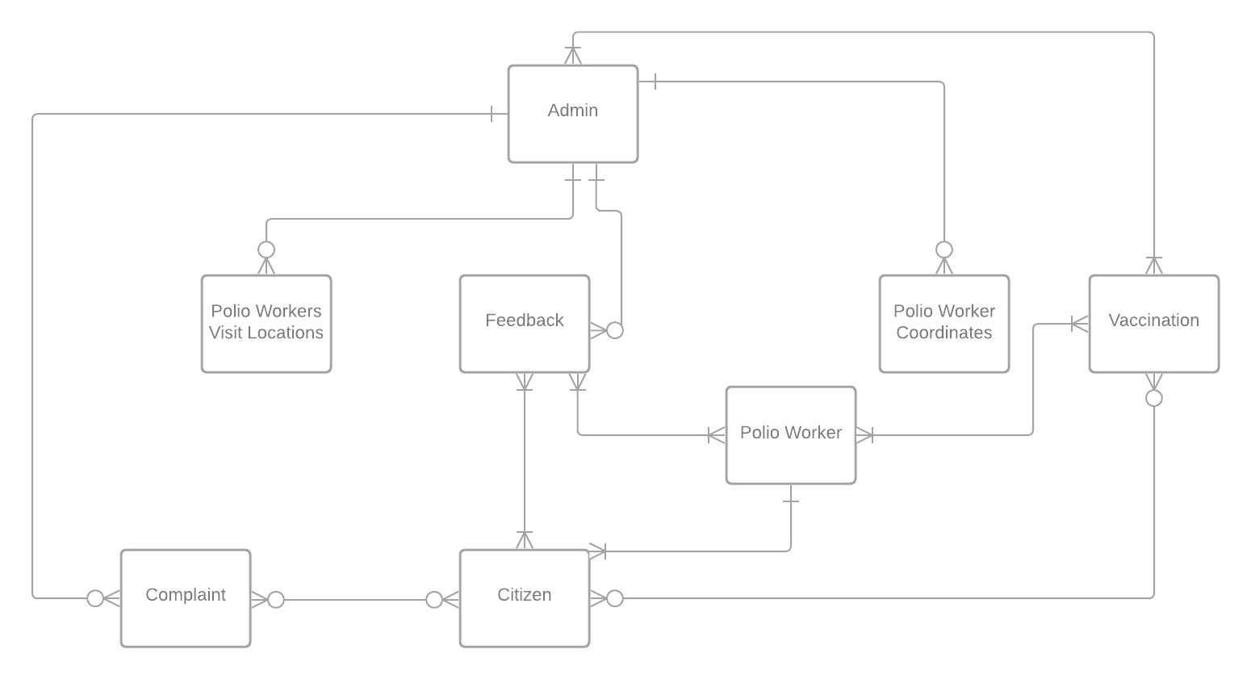

**FIGURE 7: ENTITY-RELATIONSHIP DIAGRAM**

### 5.6.1. Admin

Admin of the system which is monitoring portal or dashboard handler, the responsibilities are creating polio worker, keeping an eye on polio worker, see the progress, see the complaints or feedbacks related to one polio worker and so on.

### 5.6.2. Polio Worker

Polio worker is the second main entity of this system, polio worker will vaccinate children of citizens and will add data related to them in the database.

### 5.6.3. Citizen

Citizen is another important entity of this software, citizens are responsible for looking which polio worker will visit them in campaign days, they can give feedback about polio worker if visit has been complete or register a complaint.

### 5.6.4. Feedback

Citizens give feedback about polio worker once visit has been completed.

### 5.6.5. Complaint

Citizen complains when polio worker has missed their area during campaign or behaved not good.

### 5.6.6. Polio Worker Coordinates

These coordinated determine the location and area of polio workers which are assigned to them.

### 5.6.7. Polio Worker Visit Location

This is the location which polio worker will visit on their campaign days.

### 5.6.8. Vaccination

Polio worker visit citizen home and vaccinate children.

# 6. Chapter 6: SYSTEM ARCHITECTURE

## 6.1. SYSTEM ARCHITECTURE

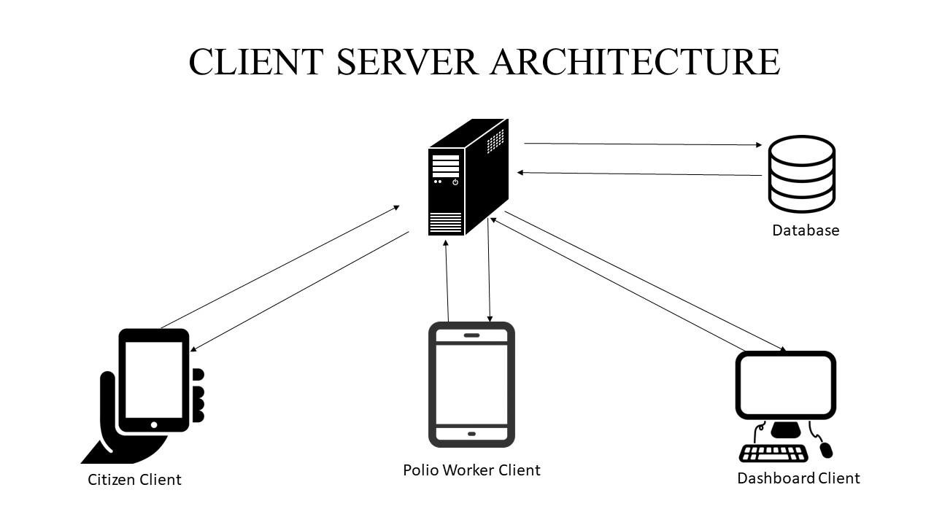

**FIGURE 8: SYSTEM ARCHITECTURE**

Our project Polio Eradication Support System follows a Client-Server System Architecture where we have three type of clients i.e. Citizen, Polio and Dashboard.

## 6.2. DATA FLOW DIAGRAM

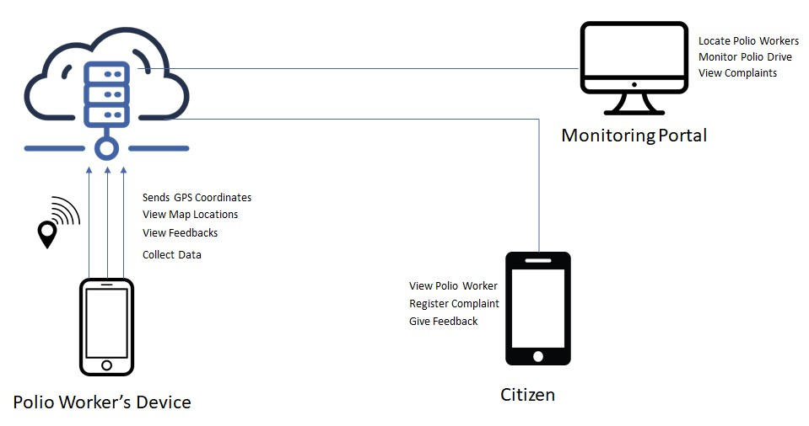

**FIGURE 9: DATA FLOW DIAGRAM**

The given figure is an abstract view of the architecture of the system we developed. In our system we have a web based Dashboard which is developed on Laravel and 2 android applications and one server which is hosted remotely. The two main applications are polio worker application and the other is citizen application. Polio worker application sends its GPS coordinates through APIs to the database and citizen application and monitoring portal get the polio worker details from database.

# 7. Chapter 7: IMPLEMENTATION AND TESTING

## 7.1. Tools & Techniques

### 7.1.1. Android Studio

Android studio provides you with an environment to build Apps for android mobiles, Tablets, Android Wear, Android TV. Android Studio is an IDE that is used for developing android based applications.

In our project we have developed 2 apps on android. The apps developed on android studio are citizen and polio worker app.

### 7.1.2. MySQL Database:

MySQL is a SQL (Structured Query Language)-based relational database management system. Data warehousing, e-commerce, and logging applications are just a few of the uses for the application. However, most commonly mySQL is used for the purpose of a web database.

The project will use MySQL to store the data of citizens and polio workers who have registered themselves.

### 7.1.3. RESTful APIs:

A REST API (also known as a RESTful API) is a type of application programming interface (API or web API) that adheres to the REST architectural style's limitations and allows interaction with RESTful web services.

Moreover, the project is sending all the data through restful APIs in the JSON objects.

### 7.1.4. Google Maps API:

The Google Maps API is a powerful tool that can be used to make a custom map, a searchable map, check-in functions, display live data that is synced with location, plan routes, and more.

### 7.1.5. Laravel:

Laravel is a PHP framework for creating custom web apps. It's a web framework that takes care of a lot of the things that are inconvenient to construct yourself, like routing, HTML templating, and authentication.Furthermore, Laravel is a server-side PHP framework that allows you to create full-stack apps, which include functionality like user accounts, exports, and order management that traditionally require a backend.

# 8. Chapter 8: RESULTS AND DISCUSSION

## 8.1. Purpose

In this section of this report, we are discussing the results after implementing our polio eradication support system. Our system comprised of two android applications i.e. Polio Worker App and Citizen App and we a monitoring portal or dashboard that is web based.

## 8.2. Polio Worker App

### 8.2.1. Splash Screen

The screen on the left is the splash screen of our polio worker app, which shows the logo we have created for our Polio

Eradication Support System.

**FIGURE 10: SPLASH**

### 8.2.2. Home Screen

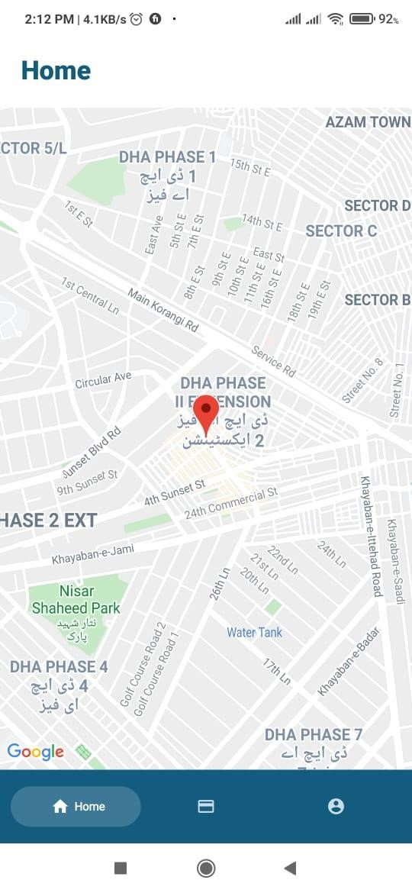The screen on the left is the home screen of polio worker app, in this screen a map is shown to polio worker which shows the current location of polio worker in the map. Through this polio worker can locate himself.

**FIGURE 11: HOME SCREEN**

### 8.2.3. Add Record Screen

This is the add record / citizen screen inside the polio worker app where polio workers can add records related to citizens while visiting their area for vaccination. What a Polio Worker can do is to enter the CNIC of the citizen whose children he is vaccinating. The polio worker will add the number of children he is vaccinating and click the add child button. After clicking the add child button the required fields will be created dynamically for adding children records in the app. The system will ask the child name and its age for entry, once successful the data will be added to our database.

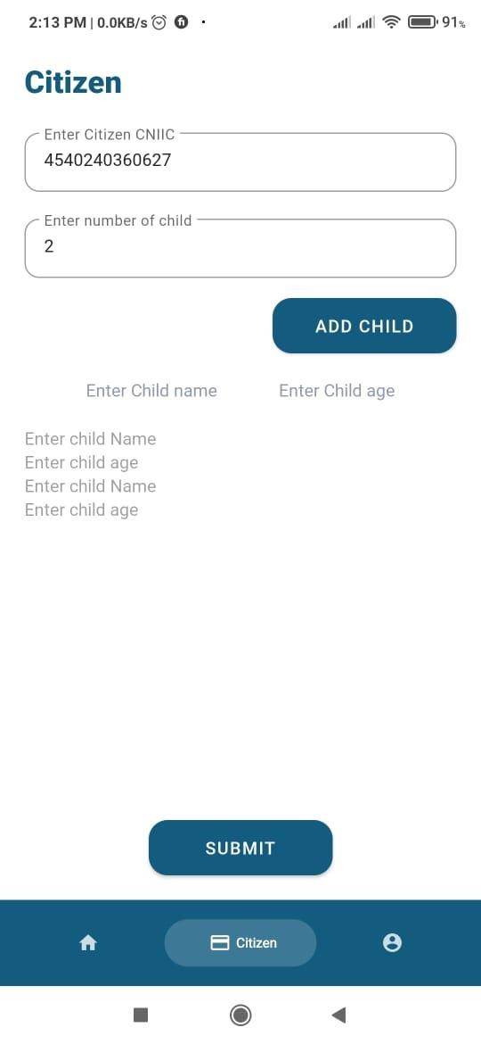

**FIGURE 12: ADD RECORD SCREEN**

### 8.2.4. Profile Screen

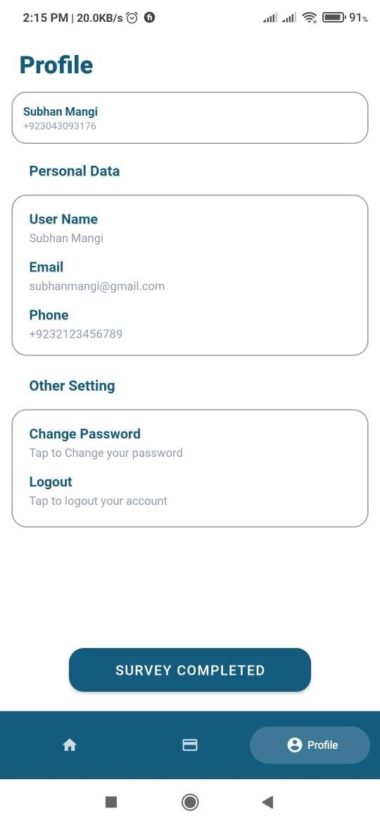The profile screen of polio worker app has two functionalities where user can see its details, update details like changing password and logout. Some details are added by a monitoring portal for polio workers so they can be edited from Dashboard.

Moreover there is a button related to Survey Completed. Upon clicking this button a notification will be generated to all citizens in the area of polio worker that polio worker has visited your area. Then citizens will either complain or submit feedback. This button will be available during initial days of the compaign.

**FIGURE 13: PROFILE SCREEN**

## 8.3. Citizen App

### 8.3.1. Home

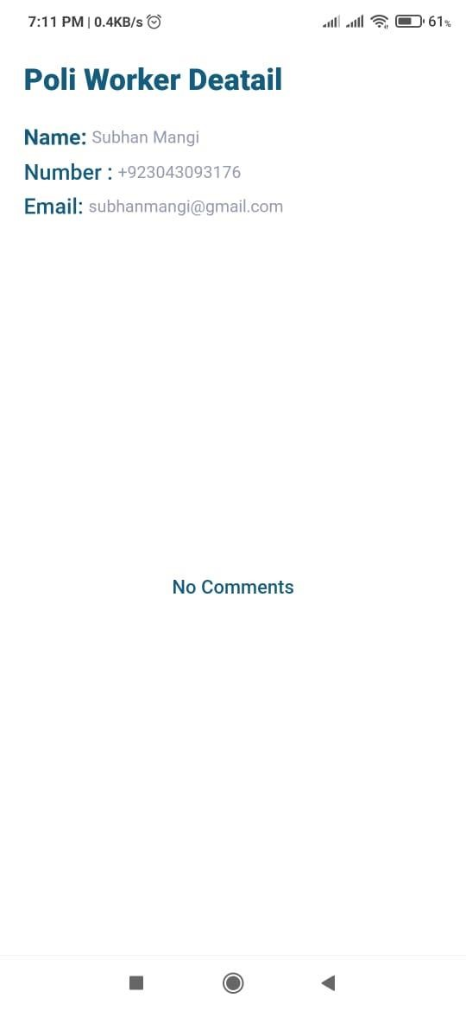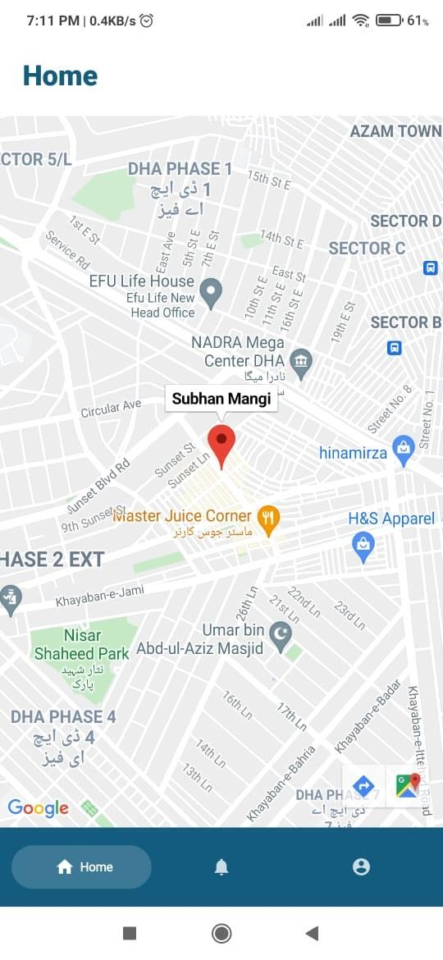

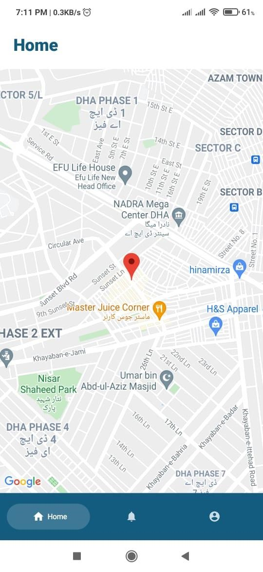

**FIGURE 16: HOME SCREEN 2 FIGURE 14: WORKER DETAILS SCREEN FIGURE 15: HOME SCREEN 3**

From this screen, Citizens can locate the polio worker of their area. After getting polio worker from database it will set the coordinates of polio worker on home screen, and upon clicking the marker the details of polio worker will be displayed. Once polio worker will complete the result then in details of polio worker activity a text field will be available to provide either feedback or submit complaint.

### 8.3.2. View Polio Worker Details



**FIGURE 17: POLIO WORKER DETAILS**

This activity should be visible if citizen click polio worker marker on map and it will show details and feedbacks about polio worker. Once polio worker will mark visit complete then a text field will also be available here for submitting review or complaint.

### 8.3.3. Notifications

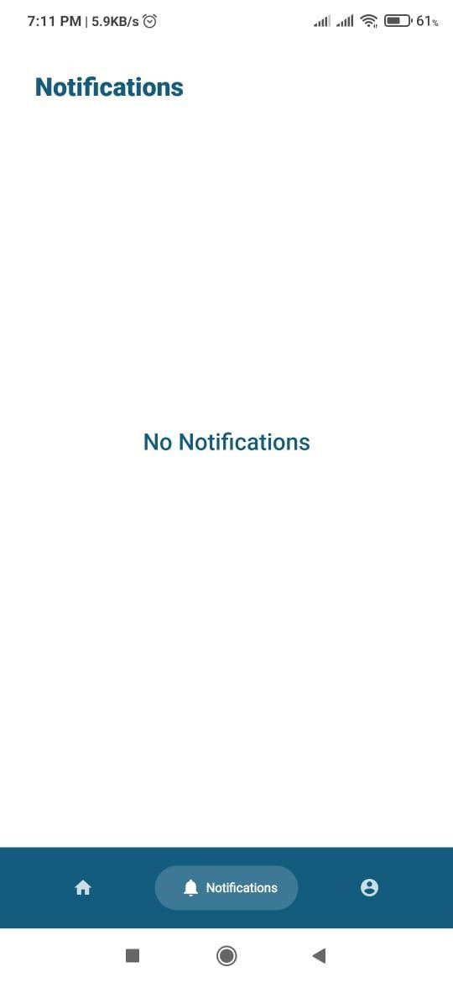This screen in citizen app is for notifications to citizen app. When polio worker will mark visit complete then a notification will be displayed in notification area of citizen app that polio worker has market survey as complete you can provide feedback or complaint about the visit.

**FIGURE 18: NOTIFICATION AREA**

### 8.3.4. Profile

This is profile screen for citizen app to view the profile details for citizen.

**FIGURE 19: PROFILE SCREEN 2**

## 8.4. Monitoring Portal

This section is about the monitoring web based dashboard as discussed briefly below.

### 8.4.1. Dashboard

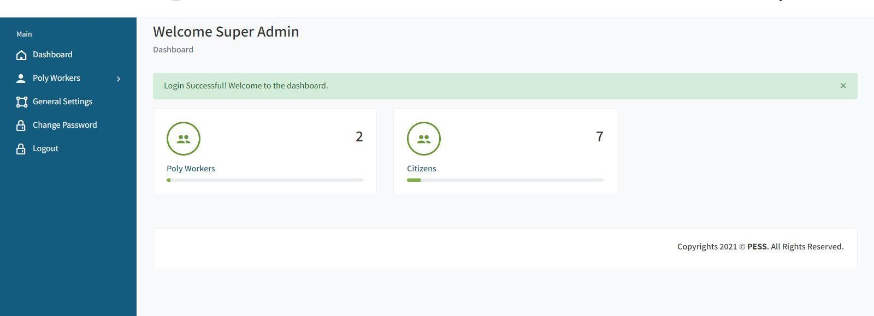

**FIGURE 20: DASHBOARD**

The dashboard of this system is web based and we have built it using Laravel. The homepage of dashboard shows overall statistics about polio workers and citizens like how many polio workers and citizens are registered in our database.

### 8.4.2. Add Polio Worker

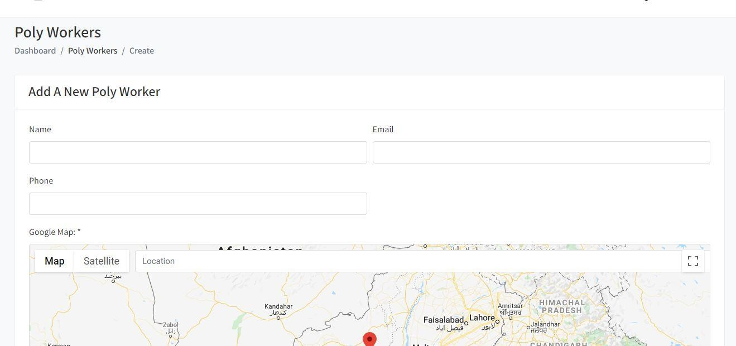

**FIGURE 21: ADD WORKER**

Through this page we can add polio worker into the system and create a new account. The location we provide here is assigned as area to polio worker for coverage.

### 8.4.3. View Polio Worker

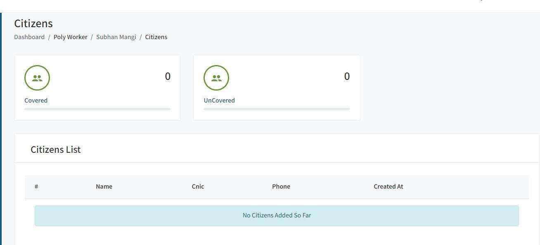

**FIGURE 22: VIEW WORKERS**

In this screen admin can see polio workers’ stats, like how many citizens are covered, records will be displayed at bottom. Moreover, it will also support citizens those are not added in our database.

### 8.4.5. View Complaints

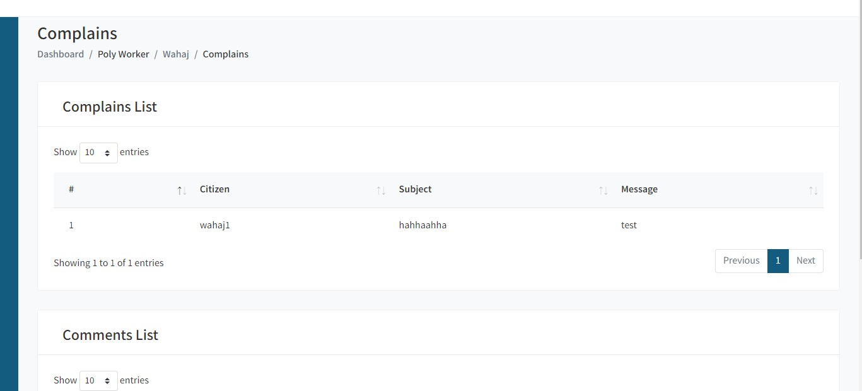

**FIGURE 23: VIEW COMPLAINS**

Here admin can see the complaints generated against any polio worker and can take action according to government policies.

### 8.4.6. View Feedbacks

**FIGURE 24: VIEW FEEDBACKS**

Here admin can see the feedbacks given to any polio worker.

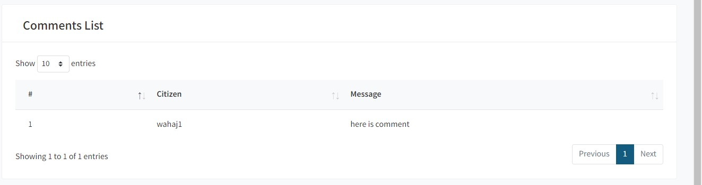

# 9. Chapter 9: CONCLUSION AND FUTURE WORK

## 9.1. Conclusion

This project was very challenging for us. Due to COVID-19 our FYP schedule was distrubed and all the students and supervisors were limited to their homes. We tried to manage and complete our project despite having limited and mobile constraints.

Our project Polio Eradication Support System (PESS) is a small contribution and act from us to help support Pakistan to eradicate polio from root level. Polio workers can forget to visit a house, at time of visit children can’t be available etc. This missing vaccination keeps polio virus alive. Our target is that no child should be left each month from polio vaccination. No doubt, for achieving this we need cooperation from citizens at their best. If government give us a chance and should opt our idea then , citizens will be able to see which polio worker will visit them, if he didn’t visit they would be able to call him or submit complain to the portal. Admins will see the statistics of polio worker and can see the complains and feedbacks about any polio worker by citizens. This idea is an spark to eradicate polio from our country by using digital system.

## 9.2. Future Work

This idea and project was new of its kind in this field. We searched a lot but could any digital system developed for polio workers or for polio complains by any private or government agency. This project is just a start for developing digital solution to fight against such virus. This project shows the worth of technology that how technology can help support humans to fight against such deadliest viruses. This idea can be expanded to a fully functional system where all the polio process can be digitalized. Complaint resolution can also be introduced in web portal where multi user can be created following the hierarchy of government, just like complaints are solved in Citizen Portal of Pakistan. Polio Worker App can have a functionality for emergency situation as if polio worker is stuck somewhere or being robbed then he can generate an emergency notification to nearest police station and so on.

# 10. Chapter 10: REFERENCES

1. Cdc.gov. 2020. Global Health - Newsroom - Polio. [online] Available at: [Accessed 11 September 2020].
2. Centers for Disease Control and Prevention (CDC). Update on vaccine-derived polioviruses. MMWR Morb Mortal Wkly Rep. 2006;55(40):1093-1097.
3. Obregón, R., Chitnis, K., Morry, C., Feek, W., Bates, J., Galway, M. And Ogden, E., 2020. Achieving Polio Eradication: A Review Of Health Communication Evidence And Lessons Learned In India And Pakistan.
4. Barbeau, S. J., Winters, P. L., Georggi, N. L., Labrador, M. A., & Perez, R. (2008, November). The travel assistant device: utilizing GPS-enabled mobile phones to aid transit riders with special needs. In Proceedings of the 15th World Congress on Intelligent Transportation Systems.
5. Kamran, H., Rehman, Z., Chaudhri, A. A., & Farrukh, S. (2019). Ide-Sharing Apps and Privacy in Pakistan: A Detailed Study on the Practices of Uber and Careem. Digital Rights Foundation.
6. Lee, S., Tewolde, G., & Kwon, J. (2014). Design and implementation of vehicle tracking system using GPS/GSM/GPRS technology and smartphone application. 2014 IEEE World Forum on Internet of Things, WF-iot 2014. [Https://doi.org/10.1109/wfiot.2014.6803187](https://doi.org/10.1109/WFIoT.2014.6803187)
7. Stapleton, J.: ‘DSDM: business focused development’ (Addison Wesley, London, 2003)
8. Highsmith, J.: ‘Adaptive software development: a collaborative approach to managing complex systems’ (Dorset House Publishing, New York, 2000)
9. Livermore, J. A. (2008). Factors that Significantly Impact the Implementation of an Agile Software Development Methodology. J. Softw., 3(4), 31-36.
10. Fisher, J. A., & Monahan, T. (2012). Evaluation of real-time location systems in their hospital contexts. *International journal of medical informatics*, *81*(10), 705-712.
11. Lin, P., Li, Q., Fan, Q., Gao, X., & Hu, S. (2014). A real-time location-based services system using WiFi fingerprinting algorithm for safety risk assessment of workers in tunnels. *Mathematical Problems in Engineering*, *2014*.
12. Lee, K. P., Lee, H. S., Park, M., Kim, H., & Han, S. (2014). A real-time location-based construction labor safety management system. *Journal of Civil Engineering and Management*, *20*(5), 724-736.
13. Gholamhosseini, L., Sadoughi, F., & Safaei, A. (2019). Hospital real-time location system (A practical approach in healthcare): A narrative review article. *Iranian journal of public health*, *48*(4), 593.
14. <https://s.financesonline.com/uploads/2017/12/agile-project-graph-1.png>

*Allah help those who help themselves – Al Quran*